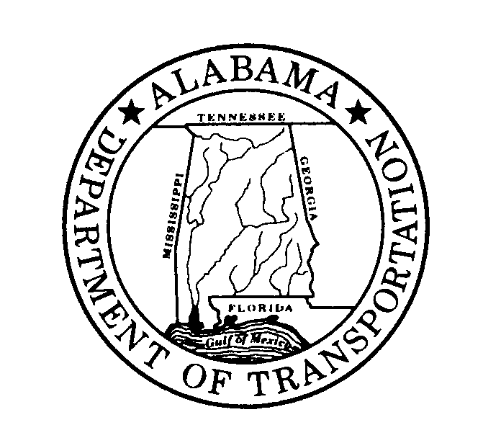 | ALABAMA DEPARTMENT OF TRANSPORTATION  1409 Coliseum Boulevard, Montgomery, Alabama 36110
Kay Ivey |  | John R. Cooper
Governor |  | Transportation Director
May 4, 2026

Ms. Lori Sokol, Executive Director
East Alabama Regional Planning & Development Commission
P.O. Box 2186
Anniston, AL 36202
ATTN: Ms. Elizabeth Wright
Subject: Cooperative Process with Non-Metropolitan Local Officials
Dear Ms. Sokol:
In accordance with 23 CFR 450 planning guidelines, the Alabama Department of Transportation (ALDOT) is required to review its consultation process with local officials every five years.

The process is in ALDOT’s Public Involvement Plan (PIP). The following is the link to ALDOT website where the PIP is located.
https://www.aldot.gov/news/pdf/ALDOTPIPFINAL202151222.pdf

We are requesting your assistance in advising your constituents and soliciting their comments on the effectiveness of the planning process. These comments should be received by this office no later than July 6, 2026. Please submit comments to Ms. Toni M. Arrington, Office Engineer Bureau or email to arringtont@dot.state.al.us.

We look forward to receiving your comments and if you have any questions, please call Ms. Toni M. Arrington (334) 242-6085.

Sincerely
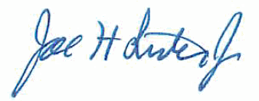
Joe H. Lister, P.E.
State Office Engineer

JHL:MH/JC/tma
C: File

